5.5

Started working on the deskew algorithm. I followed this logic: <https://becominghuman.ai/how-to-automatically-deskew-straighten-a-text-image-using-opencv-a0c30aed83df>  
starting with regular processing I converted to grey, blurred and implemented a gaussian threshold to transform the image to clearer b&w when the text in white.

I than did dilating, more intense on the x axis in order to make one big contour of the all text and looked for the min rectangle that can contain the text. The last step is finding te angle of the minRectangle and rotating it to the other direction. It worked well with the first test image:  
 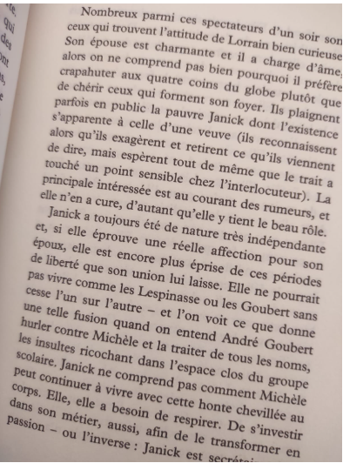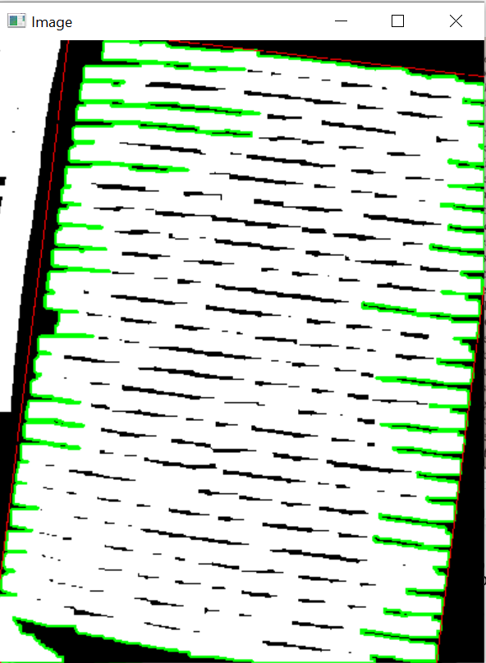

Finding the angle to be 6.932455539703369.

Unfortunately it didn’t work with the second test image:

תמונה שמכילה טקסט, ספר, נייר, מסמך

תוכן שנוצר על-ידי בינה מלאכותית עשוי להיות שגוי.תמונה שמכילה צילום מסך, טקסט, גרפיקה, קו

תוכן שנוצר על-ידי בינה מלאכותית עשוי להיות שגוי.

The algorithm here found that the min rectangle is equal to the whole screen, as there weren’t enough empty surface around the text. I realize this will be even bigger problem if the image include only text without blank margin.  
hence im going to try another approach.